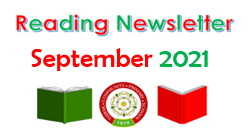

Welcome back everyone! We are kick-starting this newsletter with the most popular reads from the last school year. If you haven’t checked them out yet - here is what was most borrowed from our school library. Don’t forget, you can you use your Reading Cloud log in to request a book from home or use your class library time to find one of these great reads!

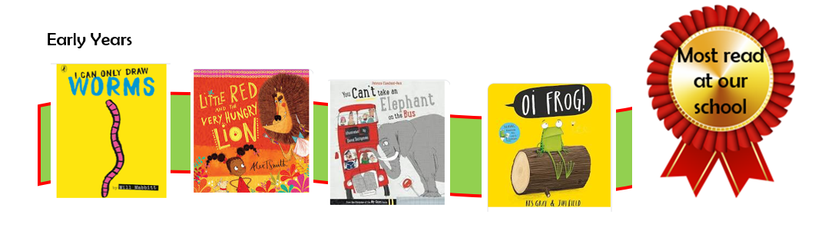

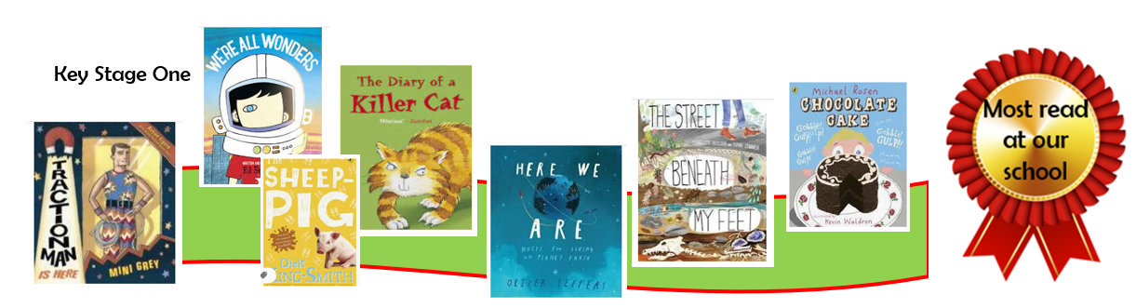
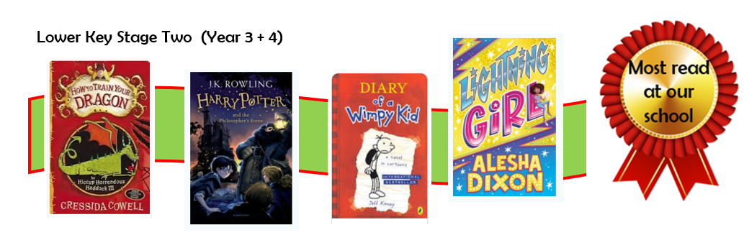

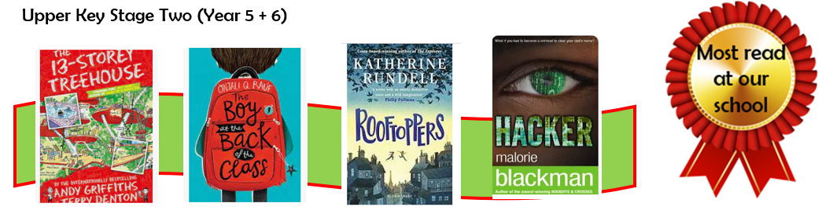

Our first Author of the Month this school year is Anthony Browne. A celebrated British children’s author and illustrator who was born in Sheffield and attended Leeds Art College. His career began as a greetings card illustrator! One of his designs for a birthday card later became the inspiration for his much-loved picture book Gorilla.
Gorillas feature in many of Anthony's books. He says: 'I am fascinated by them and the contrast they represent – their huge strength and gentleness. They're thought of as being very fierce creatures and they're not.’
Anthony has won many awards for both his writing and his illustrations.
In 2000, he received the highest international honour for illustration, the Hans Christian Andersen Award, for his services to children's literature – the first British illustrator ever to win the prize!
Anthony has been Children Laureate in the UK and has also been voted the Award for Excellence in Children’s Literature in the USA. More recently, he was Illustrator in Residence at the Tate Modern art gallery. Phew!
Here is what is coming up at our Reading Assemblies.

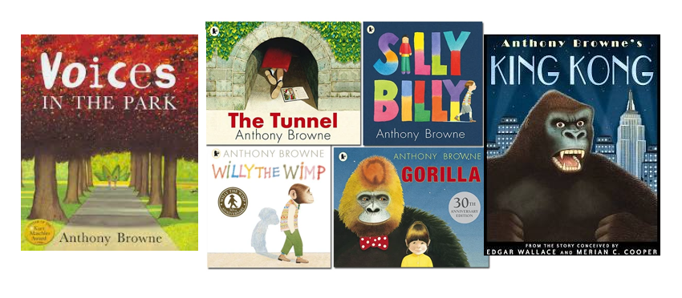

Book Match!

When we talk to pupils about their favourite authors, we often hear the same well-known writers mentioned, for example Roald Dahl, Michael Morpurgo and Jacqueline Wilson. It is great that our children can talk about these authors and that they have discovered an author they love! But, what happens when the titles run out!? To help children discover new writers that we think they will enjoy – we are introducing Book Match to the Reading Newsletters.
We begin with Roald Dahl, his fans will enjoy these

