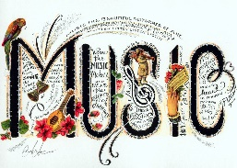

Dear Parents,

Music lessons

For the next two weeks we are putting an extra two sessions on before the next block of ten start in January. A letter will come out in the next few weeks giving dates etc for the next 10 week sessions.
The cost of these two extra sessions is £6.60

Please pay via Parent Pay where possible.

Thank you for supporting your child in this activity.

Yours sincerely

Mr R Chandler
Headteacher

