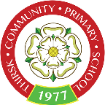

Dear Parents and Carers
Coronavirus Update as at 08.03.2020:
A coronavirus is a type of virus. As a group, coronaviruses are common across the world. Typical symptoms of coronavirus include fever and a cough that may progress to a severe pneumonia causing shortness of breath and breathing difficulties.
Generally, coronavirus can cause more severe symptoms in people with weakened immune systems, older people, and those with long-term conditions like diabetes, cancer and chronic lung disease.
We are closely following the Government’s guidance for Education Settings and any updates they issue. Head teachers are receiving Government updates on a daily basis and are aware of any changes that are being made, which they will implement.
Teachers and staff are encouraging the children to wash their hands on a regular basis and to blow their noses with a tissue.
Please can we ask you to continue to support us at home by ensuring you and your children wash hands on a regular basis.

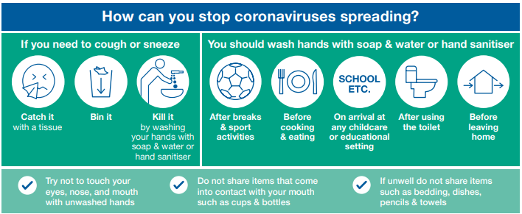
(Source Public Health England)

Returning travelers

If your family has recently travelled to or through any of the high-risk countries or you have been in contact with any relatives or visitors who have recently travelled abroad or through any high risk countries which as at 08.03.2020 are:
- Iran
- Hubei province in China
- lockdown areas in northern Italy
- special care zones in South Korea

- mainland China outside of Hubei province
- Italy outside of the lockdown areas
- South Korea outside of the special care zones
- Cambodia
- Hong Kong
- Japan
- Laos
- Macau
- Malaysia
- Myanmar
- Singapore
- Taiwan
- Thailand
- Vietnam

Please can you let the Head teacher know immediately and keep your child/ren away from school until further advice is given. Please contact the school via telephone and not in person. No family member that meets the criteria should attend school/nursery until further advice is sought.
If you have any questions or concerns please do not hesitate to contact the head teacher.
Yours sincerely

Mr Chandler

