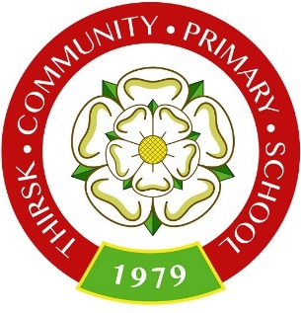
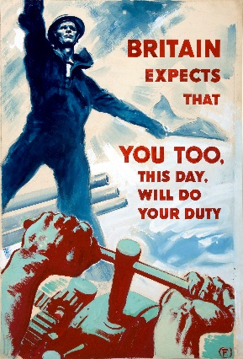
WORLD WAR II
DRESS UP DAY

Dear parents,

On Wednesday 9th December Y5 and 6 will be having a dress up day to celebrate their World War 2 topic.

The children may come to school in their outfits and wear them throughout the school day.

They will be doing a range of WW2 activities during the day.

Thank you,

Miss Gloag, Mrs Collier and Miss Holme.

