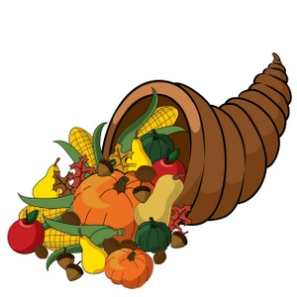

Harvest Festival Lunch 17th October 2019

We are to have a Harvest Festival Lunch on Thursday 17th 2019. Lunch will be:-
Roast Chicken with Stuffing and Gravy
Mashed Potatoes
Seasonal Vegetables
Harvest Bread
Fresh Fruit
Apple & Toffee Cake
Yoghurt
………………………………………………………………………………………………………..
Nursery Harvest Lunch Thursday 17th October 2019
My Child……………………………………………………………………………………………………………………
I enclose £1.80 cash I have paid By Parent Pay at the office

Signed ………………………………………………………………………………………………………………

