SUMMER HOLIDAY EVENTS AT
THIRSK COMMUNITY LIBRARY 2021
LITTER ART with CHRIS
Sat 24th, Tues 27th July & Fri 27th Aug 2 – 3.30
Cost £1 per child
Join in and help create our giant litter art world map with local artist Chris Geeson.
Complete a country or an endangered animal. All clean litter provided. Suitable from age 3.

NATURETOWN with ZOOLAB©
Wed 28th July & 1st Sept 2.00 – 3.00 (ages 4 -11)
Cost £3 per child (children only). Family ticket £5 for 2 or more children
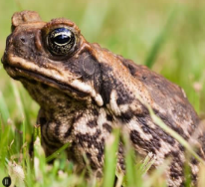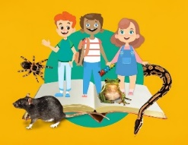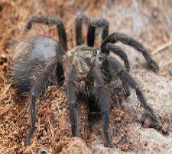
The fabulous ZOOLAB are bringing animals for you to meet and enjoy the Naturetown story.
(Parents of children under 8 must stay in the building.)

MINDFUL ANIMAL DRAWING
Mon 2nd, Tues 10th Aug & Thu 2 Sept 10 – 11 & 11 – 12
Cost £1 per person
Relax with some doodling. No artistic skill required! Adults and children 7+ welcome.

CREATE & PAINT A CLAY MODEL ANIMAL
Thurs 12th Aug 1.30 – 2.30 & 3.15 – 4.15 (ages 5 upwards) – create
Thurs 19th Aug 1.30 – 2.30 & 3.15 – 4.15 (ages 5 upwards) – paint
Cost £1 per person
Enjoy getting messy and create a mini beast or animal; leave to dry, return to paint.
ENDANGERED ANIMAL MASKS
Fri 30th July 10 – 12 – create
Fri 6th Aug 10 – 11.30 – paint
Creating paper maché masks first week and painting the week after. £1 per person; from 7yrs
STORYTIME FRIDAYS
Fridays 30th July; 6th, 13th, 20th, 27th Aug & 3rd Sept 2 – 3pm
Bring a rug and enjoy stories under the tree (indoors if wet) – FREE!
Booking is essential for all these activities and places are limited so please book early by phone: 01609 534589
email: library@thirskcommunitylibrary.org.uk
or visit Thirsk Community Library, Meadowfields, Chapel Street, Thirsk YO7 1TH
Phone: 01609 534589 email: library@thirskcommunitylibrary.org.uk
Thirsk Community Library, Meadowfields, Chapel Street, THIRSK YO7 1NQ
www.library@ thirskcommunitylibrary.org.uk follow us:

Summer Reading Challenge 2021
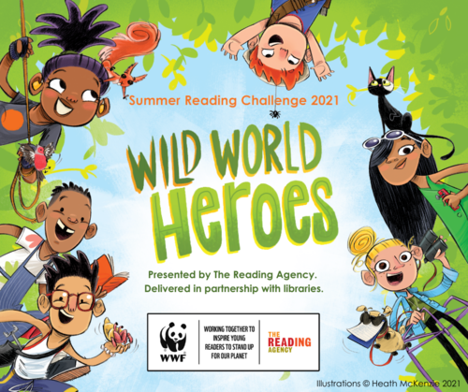

We challenge all 4 - 11 year-olds to read 6 books over the holidays!

Our theme is Wild World Heroes so discover how to save our planet with this summer’s reading challenge. Come to the library after school on Mon, Tues, Thurs or Fridays before 5pm or between 9.30 - 3 on Sat 3rd July or 10th July to sign up or throughout the holidays.
You will get a record card and stickers and rewards every time you come in to choose more books. When you have read 6 books you get a medal and a certificate all FREE! Also we have Buzzy Bee’s Honey Hunt for preschool children with stickers and rewards.
