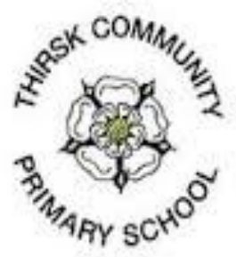
Nursery Newsletter Autumn Term 2 2017

Welcome back! We are really eager to get started! If we had to pick a favourite term, it would probably be this one! With Halloween, Bonfire Night and Christmas all in the same term, we are going to be VERY busy bees! We would like to start this letter by wishing a very warm welcome to: Archie, Ben, Lacey, Isla and Jessica. The children of Busy Bee class are excited about our new starters and can’t wait to help them settle in.

Our theme for this half term is:
Celebrations!

Please remember this is a ‘loose’ theme and that the vast majority of our planning happens one day for the next, or in the moment! We support and extend children’s development using what they are interested in and what is meaningful to them. Our weekly news slip always details what has been pre-planned by Mrs Wall and what the children have been focused on in their own initiated work. It is usually in the child initiated work that we see the deepest learning take place, so it’s always interesting to see what has taken their fascination during the week.
On this theme, we are starting a new way of recording our observations. The new method will show the ‘thread’ of learning your child has taken from one session to the next, or at different stages in the same day. They will also detail how the adult working with them has supported the learning and development, as well as how it has been extended. These are quite lengthy pieces of work; each child will receive one a term. We will be asking for parent input with them, to gleam an understanding of what you feel your child has mastered and what you think is important for them to do next. It is our hope that these new ‘Learning Stories’ will really highlight the journey your child is on, as well as the role of the adult at school in this. Most importantly, they highlight that play really is the vehicle of learning for our young children, that this to them is their work.

Personal, Social and Emotional Development

We will be starting a ‘buddy’ system to help our new starters settle in. Children who wish to be a buddy will be invited to ‘apply’ for a position and explain what makes a good friend. They will have the chance to lead short ‘settling in’ games and to report back to the adults in the class about how our new starters are getting on. Other children will have the opportunity to become a member of the ‘Put it away police’, a ‘crack down unit’ on the tidiness of the class! Our young children love responsibility and the feeling of doing something an adult might do- we may find the next generation of teachers!

Communication and Language
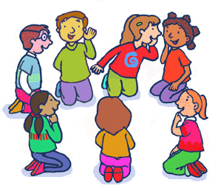
This half term we will begin our Show and Tell sessions on a Friday. We invite children to bring something in to talk about, but nothing too big or too precious please! A large part of Communication and Language in the Early Years is the ability to answer an open-ended question (a question that requires more than a one word answer). We have introduced an ‘Island of Interest’ in the class. This is an area with ‘interesting objects’ with questions based around them. They are designed to really get the children thinking and speaking, using extended sentences with descriptive language. Finally, we will also be learning the songs that will form our Christmas Production!

Physical Development
During this half term we are going to focus on health and safety. A large part of the curriculum for the nursery age group is learning how to use equipment in a safe way. Also included is learning about what is an acceptable risk to take and what is an actual real danger. Bonfire Night offers many talking points around this. In the new year we are hoping to introduce a wood work area. We will be introducing various tools in other areas of provision on the run up to this, to model and demonstrate how to use them safely. In this way the children will be prepared with the knowledge and understanding they need to keep themselves and others safe.

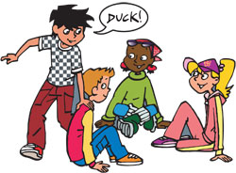

Literacy
The children will be involved in shared reading and storytelling every day. All the stories are based on our theme. Below is a list of stories you can find on YouTube that we will be covering in class. You might enjoy sharing these with your children at home.

Room On The Broom
Owl Babies
How To Catch A Star
The Night Before Christmas

Our phonic work will be based around several aspects. Exactly what your child will be doing will largely depend how long they have attended nursery. Some children will be learning about sound discrimination: loud/ quiet, fast/ slow, high/ low, long/ short. Others will be thinking about syllables within words, for example: ‘king’ is a one syllable word, ‘carpet’ is a two syllable word, and ‘spaghetti’ is a three syllable word. Some children will be learning to blend and segment short words, for example being asked to sound out ‘red’ after it being spoken to them, r-e-d. Or, having to blend the sounds r-e-d to say red (this is often harder). The phonics related PACT task will indicate what your child is currently working on.


Mathematics
Bonfire Night offers us many opportunities to explore counting up and counting down. We will be learning action rhymes and songs to help the children understand that as we count up the amount increases, and as we count down the amount decreases. This will work towards the understanding that when we subtract the amount left is smaller and when we use addition the total amount is larger. Using the mathematical language associated with addition and subtraction is the building block on which mental methods of maths working are built.

Understanding the World
We will be focusing on the strand ‘People and Communities’ from this area of learning this half term. The spotlight will obviously be on Christmas! In the Early Years we focus on what Christmas means to individual people, eg what children do outside of school to celebrate Christmas. The underlying learning intention is that children start to learn that some people celebrate Christmas in the same way, some celebrate it in a different way, and others do not celebrate it at all.

Expressive Arts and Design

This term we will be encouraging the children to mix different types of media together. We will be showing how you can combine various resources to create a picture or a modal. We really want our children to be able to look at a resource and think about what it might be best used for. We also want them to have the confidence to try different combinations, so that they can create truly abstract art! With Bonfire Night and Christmas being in this half term, there will be quite a bit of glitter on the go! The children will also be using fluorescent and metallic resources. Our planned activities will focus on the dark and light, as well as shape and pattern.

What can I do to help/enhance my child’s learning this term?

Play, Learn and Children Together Books (PACT Books)
These books are for home and school communication. Mrs Wall will include a PACT task each week for the children to complete at home. This will be related to what the children are learning about in class. There will also be a news slip, so you are always informed of our teaching and learning at school. The books are given out on a Monday and collected in on a Friday. Please feel free to include any information from home that you would like to share with us in these books. This could be something your child is enjoying doing at home or information about a new achievement. The more you know about your child, the better we can provide for them!

As always, if there is anything you think we need to know about your child please come and speak to us. Our door is always open! We appreciate that drop and pick up times can be quite hectic. Mrs Wall is in school from 7.30am each day and would happily take a phone call or an early visit into the classroom.
Mrs Wall, Mrs Bowen and Mrs Wilkinson.

